**EXPLORING GROUNDWATER POTENTIAL EVALUATION AT OBAFEMI AWOLOWO UNIVERSITY, PARKS AND GARDEN, IFE-CENTRAL LOCAL GOVERNMENT, ILE-IFE, SOUTHWESTERN NIGERIA THROUGH RESISTIVITY DATA ANALYSIS**

**CHAPTER ONE**

**INTRODUCTION**

* 1. **BACKGROUND**

Water is a vital resource for most basic human needs which cannot be over-estimated. The distribution of groundwater is a critical factor in exploration, hence the need for prospecting of groundwater aquifers in the subsurface.

However , groundwater prospecting in complex basement terrain can be a challenge due to the complex nature of the geological formations (Sunmonu et al, 2018; Wannamaker et all, 2016). Prospecting for groundwater in basement complex terrains requires in-depth understanding of the geology, hydrogeology, and groundwater flow dynamics, as well as the use of appropriate geophysical and drilling techniques(Olobaniyi et al, 2016).

Exploration of groundwater in complex basement environments necessitates meticulous mapping of lineaments, such as fractures, fault zones, and joints, which serve as crucial groundwater pathways and storage locations(Hasan et al., 2018).

To overcome this challenge, geophysical methods such as the electrical resistivity method is employed to investigate the subsurface. The electrical resistivity technique is a non invasive geophysical method that measures electric current flow through the subsurface, simply conductivity and resistance to flow of electric current. This helps to determine the saturated and dry zones in the subsurface since fluid is conductive and less resistance, hence areas with high resistivity values are indicative of low water reserves and those with low are indicative of potential aquifers.

The Electrical resistivity method is preferred to other geophysical methods due to its effectiveness in accessing subsurface conditions, give high resolution image of the subsurface and cost of carrying out relative to other geophysical method.

* 1. **DESCRIPTION OF THE STUDY AREA**

The study area is behind Obafemi Awolowo University Conference centre situated in Ife Central Local Government area of Osun State, Southwestern Nigeria. It has a 817 meters perimeters, width of 169 meters and length of 244 meters, located on latitude 7.4767446 and longitude 4.5813186. Ifewara falls within the Ilesha schist belt and is underlain by gneiss, migmatite and metasediments ranging from Precambrian to Palezoic age. The area is easily accessible by roads, both major and minor connecting to the correctional facility.

* 1. **RELIEF, CLIMATE AND VEGETATION**

The studied area falls within the tropical climate region having distinct wet and dry seasons with landforms shaped by geological processes. The average annual temperature is  33° degrees and the average rainfall ranges from 1125 mm in derived savanna to 1475 mm in the rainforest belt of the state . The seasons are Rainy season (April to October), harmattan season (November to January) and dry season (February to March).

The vegetation of Osun State has been described as lowland forest zone (Keay, 1959), semi-deciduous moist forests (Charter, 1969) and GuineoCongolian forest drier type (White, 1983).

**1.4 PREVIOUS WORK**

The electrical resistivity method has applications in diverse fields, including engineering and environmental studies. The relationship between the resistance of the subsurface, that is the earth crust to the flow of electrical current can be used to interpret the probable lithological layers and their thicknesses. This opposition to current flow brings about its relevant applicability in groundwater investigation, since subsurface water due to its impurity by conductive ions has made it conductive to the current flow. Structures housing groundwater in the subsurface would give low resistivity readings, which brings us to the literature reviews, where it has been employed in groundwater investigation.

Olusegun *et al*. (2016) carried out geophysical investigation of groundwater potential and aquifer protective capacity around Osun State University using electrical resistivity method. Schlumberger array set up was used for the four vertical electrical soundings(VES) carried out during the survey. The results of the study were used to identify the high groundwater yield zones and the safety for domestic consumption due to the very low resistivity readings acquired.

Abel *et al*. (2023) carried out groundwater exploration using the electrical resistivity method at the Akoka Lagos Nigerian Community Federal college of Education. Schlumberger array was used for the thirteen vertical electrical soundings carried out during the course of the study. The results interpreted showed that for efficient groundwater yield, borehole depth should not be less than 150m due to the population explosion.

Minin *et al.* (2017) carried out geology and geophysical investigation using electrical resistivity method in parts of Minna, North-Central Nigeria. Horizontal profiling using Wenner array was used to determine the lateral variations in apparent resistivity at various depths and Eighty vertical electrical soundings were carried out using Schlumberger array. The combined interpretation of the Horizontal profiling(HP) and vertical electrical soundings(VES) were used to delineate the fractures and their trend in the area that could be potential aquifers for groundwater.

Lawal *et al.* (2020) carried out geophysical investigation of groundwater depths in Igbogbo, Ikorodu, Lagos State, Nigeria. The investigation was carried out using thw electrical resistivity method, employing vertical electrical sounding(VES) and 2D imaging technique. A total of 24 VES was carried out using Schlumberger electrode configuration and Wenner array for the 2D imaging of the subsurface. The results of the processed resistivity data showed that the sand layer within depth ranges of 14.1m to 31.8m of the study area is the best aquiferous layer.

Umar et al. (2024) also carried out groundwater investigation using electrical resistivity method at Alhudahuda College Zaria, Kaduna State, Nigeria. Ten vertical electrical soundings using Schlumberger array were carried out on the site. The result of the survey revealed the depth and thicknesses of the subsurface layers. The fractured zones were found to be within the depth ranges of 2.07m to 8.68m and 6.01m to 24.50m.

**1.5 AIMS AND OBJECTIVES**

The aim of the study is to identify the groundwater aquifer(s) within the Kosere correctional centre and zone(s) of high yeild.

The objectives are to:

1. create the traverses for the vertical electrical sounding(VES) and the 2D imaging within the correctional facility.
2. acquire resistivity data along the identified traverses.
3. delineate the subsurface layers, depths and thicknesses through the geoelectric section
4. use the geoelectric section to delineate the groundwater aquifers zones and depth to fracture zones.

**1.6 SCOPE OF STUDY**

During the course of this study, electrical resistivity method will be adopted. Two survey techniques will be used, the 1D vertical electrical sounding(VES) and 2D imaging (combined horizontal profiling and vertical electrical sounding).

Prior to the geophysical acquisition of data, relevant map of the study area would be acquired to create traverses, there will be visits to verify the accessibility of the area. Literature reviews on the geology and previously carried out surveys would take place.

Observing trends from literature reviews on similar geophysical surveys, the schlumberger array has been widely used for vertical electrical sounding, the dipole-dipole array was also used for the 2D imaging technique. The VES and 2D imaging section would be used as complementary methods to verify credibility of the acquired data.

The Schlumberger array will be used due to the little or no movement of the potential electrodes making it less labour intensive compared to the other arrays. The Dipole-dipole array would be used for the 2D imaging due to its high depth of penetration and spatial resolution. The closely spaced potentials and current electrodes are very sensitive to vertical and lateral variations in resistivity which makes it possible to create much more detailed images of the subsurface.

**CHAPTER TWO**

**LITERATURE REVIEW**

**2.1 REGIONAL GEOLOGY**

The exploration sit lies within the basement complex rocks of the Southwestern Nigeria (see fig 3). Rahaman (1988), based on both their petrographic and petrologic properties classified the basement complex rocks into six major groups;

1. Migmatite -gneiss - quartzite complexes
2. Slightly migmatised to non-migmatised metasedimentary and non meta igneous rocks. They are also referred to as Newer metasediments or younger metasediments and are widely prevalent in schist belts.
3. Charnockitic, gabbroic and dioritic rocks.
4. Members of the older granite suite.
5. Metamorphosed to unmetamorphosed calc-alkaline volcanics and hypabyssal rocks.
6. Unmetamorphosed dolerite dykes, basic dykes and syenite dykes.
7. **The Migmatite-gneiss-quartzite complex:** This petrographic unit covers over 30% of the total surface area of Nigeria (McCurry, 1976) and it is regarded as the oldest. This comprises quartzite and quartz schist, biotite and biotite-hornblende gneiss, and small lenses of calc-silicate rocks. (Archaen to upper proterozoic, kiberan and Eburnean orogenesis).

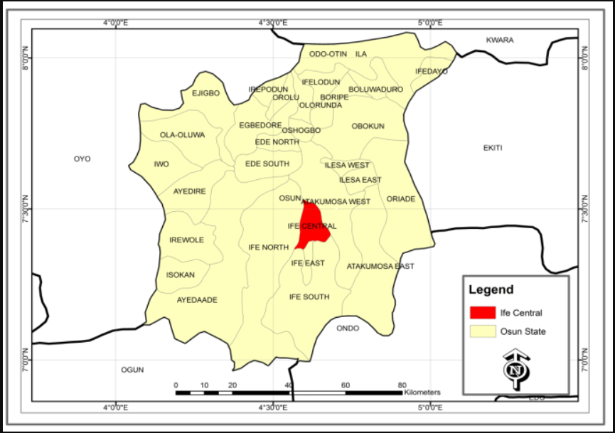

Figure 3: Map of Osun State showing Ife Central Local Government Source: Cooperative Information Network (COPINE), OAU, Ile-Ife 2015.

1. **Slightly Migmatised to Non-migmatised metasedimentary and metaigneous rocks**: These rocks have been called different names ranging from ‘Newer sediments' by Oyawoye (1964), 'schist belts' Ajibade (1976)and 'younger metasediments' McCurry (1976) respectively. These rocks have been extensively studied by different people. However, researches are still been carried out on these rocks. The schist belts consist essentially of supra-crustal sedimentary successions containing minor volcanics, basic sills and lavas (amphibolites) and ultra-mafites which have suffered polyphase deformation and metamorphism under low to medium grade conditions (Rahaman (1973),(1988); Ajibade (1976); Adekoya (1991,(1996). A total of 12 schist belts have been mapped within the Nigerian basement complex, three of which fall within the Southwestern part of Nigeria, they include the Ilesa, Igarra and Iseyin-Oyan river schist belts respectively; (Achaean to upper proterozoic, Eburnean orogeny). Charnokitic, Gabbroic and Dioritic rocks: These rocks occur within the amphibolite facies, although their mineral assemblages indicate that they belong to the granulite facies (Rahaman and Ocan, 1981; Olarewaju, 1981). On the basis of structural and petrographical characteristics, the following types of
2. **Charnockitic, Gabbroic and Dioritic rocks**: banded or gneissic charnockites, coarse (often homogenous) porphyritic foliated charnokites and bauchites, fine to medium grained foliated basic charnockites and dioritic rocks of charnokitic affinit) respectively (Pan African, 600± 150ma)
3. **Older granites**: These rocks vary in composition from granodiorite to true

granites and potassic syenite. These rocks are the most obvious manifestations of the Pan-A frican Orogeny in this part of West Africa. They occur largely as distinct plutons often of batholithic dimensions and of limited compositional and petrographic types (Pan African, 600 ± 150ma).

1. **Metamorphosed to unmetamorphosed Alkaline Volcanic and Hyperbasal rocks**: The most important lithologies which form these rock units include volcanic agglomerates, tuffs and rhyodacites (Pan African, 600± 150ma)
2. **Unmetamorphosed dolerite dykes, basic dykes and syenite dykes**: These are invariably the youngest of all. Dolerite dykes are widely distributed within the Nigerian Basement Complex (Deswardt, 1953). A typical example is the Ibadan dolerite dyke whose emplacement is thought to represent the termination of the Pan-African Orogeny (Grant, 1970, 1971). The Igarra syenite dyke has been extensively studied by Rahaman and Odeyemi (1974),Odeyemi (1976), Obasa (1981) as well as others. Their emplacement is also considered to be one of the last events to affect the geology of the area (Pan African and later).

**2.2 GEOLOGY OF THE STUDY AREA**

The Obafemi Awolowo University area falls within the basement complex region. The major rock types in the study area consist of gneisses and migmatite complexes, schists, pegmatites and charnokitic rocks.

**2.3 HYDROGEOLOGY**

Groundwater is known to occur in porous and permeable geologic unit known as aquifers. The porosity determines the amount of water that can be held in storage and the permeability determines the ease with which the aquifer gives up water. These two parameters are believed to influence the yield of boreholes sunk into aquifers.Oteze (1981) suggested that the presence of an aquifer or aquifers in a particular geograpiiicai region dominated by crystalline basement complex rocks is dependent,among other factors, on;

1. the degree of fracturing of the basement rock
2. the thickness of the weathered horizon overlying ile basenneni
3. the absence or presence in minimal amounts of clays at the top of the

weathered horizon to allow for the infiltration of surface water into the

weathered horizon.

Aquifers can be classified into two basic types, the unconfined and the confined types. An unconfined aquifer is one in which the water table serves as the ipper and lower surface of the zones of saturation and aeration respectively, while ε confined aquifer is one in which groundwater is restricted naturally under a pressure

significantly greater than atmospheric pressure by overlying, relatively impermeable

strata.

Although groundwater occurrence may be localised in basement complex terrain, the great number of hand-dug wells with considerable water-yielding capacities attests to the suspicion that significant quantities of water are available.

**2.4 THE ELECTRICAL RESISTIVITY METHOD**

The electrical resistivity method is a geophysical method of prospecting for physical properties of earth materials(soils and rocks included), that is the apparent resistivity of the ground, by introducing artificially generated electric current through grounded electrodes while the resulting potential difference is measured between a pair of electrodes.

All materials including soils and rocks have an intrinsic property called electrical resistivity, which governs the relation between the current density and the gradient of the electric potential . Lateral and vertical variations in the resistivity of subsurface materials produce variations in the applied current and the potential distribution measured on the surface and thereby give information about the composition, extent and physical properties of the subsurface materials.

The electrical resistivity method is one of the most widely employed geophysical methods due to its relevant applications in groundwater investigation, mineral exploration, geothermal studies, engineering site investigation, environmental studies and oil exploration.

The relevancy of the method in groundwater exploration is due to the significant electrical resistivity contrast that normally exists between the weathered zone, the fractured zone and the highly resistive fresh bedrock.

**2.4.1 BASIC THEORY OF ELECTRICAL RESISTIVITY METHOD**

Consider a cylindrical wire of length (L) and cross-sectional area (A) carrying current (I) shown in Figure 2.4.

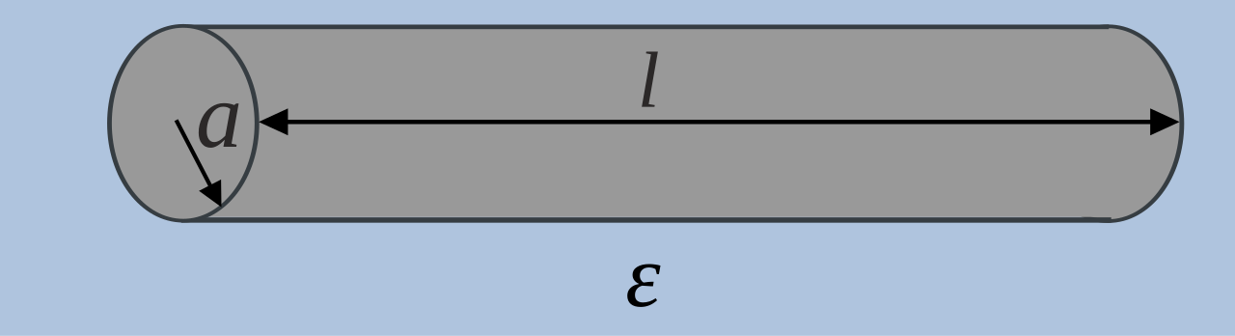

Figure 2.4: A cylindrical wire carrying current (Source: wikimedia.org)

**CHAPTER THREE**